**Ordering Sendouts in MiChart**

Here is a screen shot from MiChart showing what the Order screen looks like.

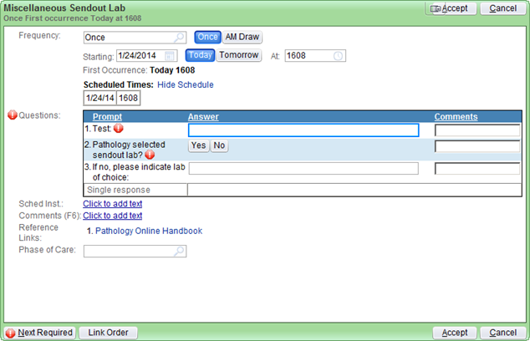

1. Indicate the test name (preferable match exactly what the desired reference lab has called the test)
2. Pathology has many labs already selected for most sendout tests. This may be due to electronic interfaces, cost savings, report layout, etc. To use one of the preselected labs, mark “Yes”.
3. If you would like to provide a suggested lab, it should be noted that not all suggestions will be utilized. There are criteria that labs must fall into. The lab will be researched and if there is a problem, someone from Pathology will page you to discuss. (either the Sr Clinical Technologist, the Path resident on call, or the Medical Director)
4. “Destination Lab paperwork completed?” Complete outside lab paperwork and send with the patient to the draw station. Most times there are blanks for patient history, or medications, that are best provided by the caregiver for the patient.
5. In the “Comment (F6)” line, add any specimen requirements or handling instructions, if kown.
6. Be sure to release the order (s), so phlebotomy will be able to collect it when the patient presents at a draw station.

Extra tips:

* If the patient is an outpatient, copies of insurance card (s) may be needed.
* If the patient is an inpatient, expensive genetic testing will be reviewed by Pathology. You may get a call from the Path resident on call, or the Sendout Medical Director to discuss the case, before approval is given.
* To request tissue blocks from Surgical Pathology for sendout testing, please use the following online form.

http://www.pathology.med.umich.edu/forms/lib_req/

Request that the sample be delivered to our lab, 2F361. Test requisitions will then need to be faxed to us, in order for the specimen to be processed and sent out.

For questions, Sendouts hours are:

6am to 10pm Monday through Friday

2pm to 10pm on Saturday

Phone number: 734-936-6777 option 1

Fax number: 734-647-6792

Room 2F361 UH (in the back of Specimen Processing)